|  |  |
| --- | --- |
| EGC_Black | Student Name \_\_\_\_\_\_\_\_\_\_\_\_\_\_\_\_\_\_\_\_\_\_\_    **Eastern Goldfields College**  Mathematics Essential Unit 3 2018  Test 31 |
| **Working Time: 20 minutes** | **Marks: 19 marks** |

**Calculator Free (No notes or calculator allowed)**

**Question 1** **(4 marks – 1,1,1,1)**

Circle the correct answer in each of the following multiple-choice questions.

### The three sides of a right-angled triangle measure 40 m, 41 m and 9 m. The length of the hypotenuse is:

### (i) 9 m (ii) 40 m (ii) 41 m (iv) none of these

1. A map has a scale of 1 : 5000. 5cm on the map is equal to how far in real life?

### (i) 5000 cm (ii) 2500 cm (iii) 25 m (iv) 250 m

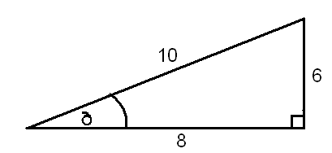c) In relation to the angle, which is the opposite side?

### (i) 10 (ii) 8 (iii) 6 (iv) none of these

1. The value for *x* in the diagram is given by:

12\_\_

sin 30O

12\_\_

tan 30O

### (i) 12 x sin 30O (ii) 12 x cos 30O (iii) (iv)

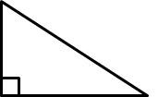

x

12

30˚

**Question 2 (2 marks)**

Match each shape to it’s net

****

### Question 3 (4 marks – 1,3)

1. Label the different views for the following 3D shape.

|  |  |  |  |
| --- | --- | --- | --- |
| Front | View From \_\_\_\_\_\_\_\_\_\_\_\_ | View From \_\_\_\_\_\_\_\_\_\_\_\_ | View From \_\_\_\_\_\_\_\_\_\_\_\_ |

1. Draw the shape in its different views.

|  |  |  |  |
| --- | --- | --- | --- |
| Front | Plan | Front Elevation | Side Elevation |

**Question 4 (3 marks)**

Miss Jones, Mr Elliot and Mr Cook have all constructed pillow forts as seen in the diagram below. They wish to run cable to all 3 forts so that they can connect their laptops.

How much total cable will be needed?



8m

‘



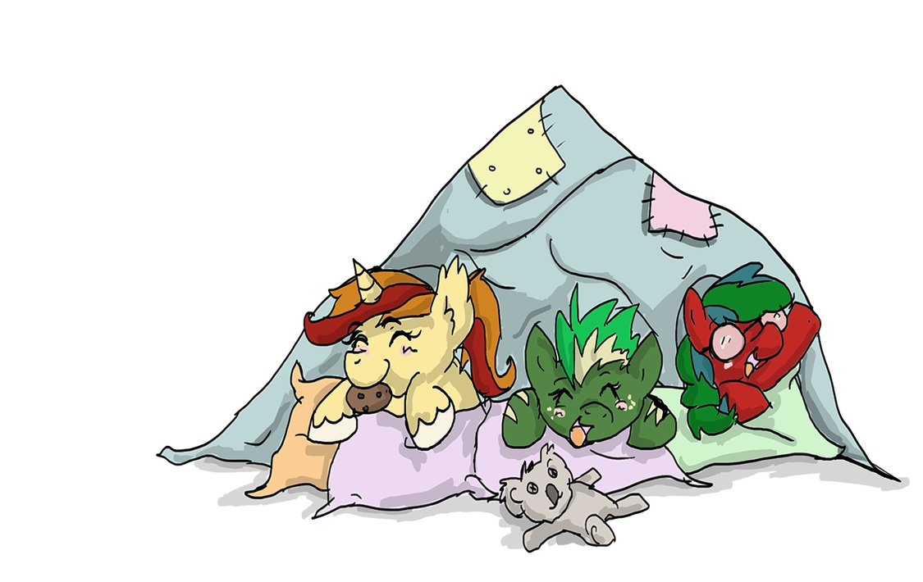

6m

### Question 5 (6 marks)

Create an accurate scale drawing of the diagram on the right to determine how far the boat is from each station.

20km

Use scale 1 = 200000

|  |  |
| --- | --- |
| EGC_Black | Student Name \_\_\_\_\_\_\_\_\_\_\_\_\_\_\_\_\_\_\_\_\_\_\_    **Eastern Goldfields College**  Mathematics Essential Unit 3 2018  Test 31 |
| **Working Time: 35 minutes** | **Marks: 29 marks** |

**Calculator Assumed (Formulae sheet and one A4 page of notes)**

### Question 6 (2 marks)

Draw and name the following shape, according to the description given below:

|  |  |  |
| --- | --- | --- |
| **Description** | **Name** | **Drawing** |
| A 3D shape that is made up of 5 faces – 2 triangles and 3 rectangles. |  |  |

**Question 7 (3 marks)**

A ladder 12 m long leans against a wall. If it forms an angle of 400 with the ground, how far is the bottom of the ladder away from the wall?

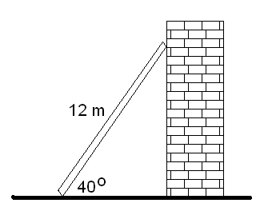

**Question 8 (5 marks – 3,2)**

|  |
| --- |
| 1. A boy notices a bird sitting at the very top of a 10m tall tree. If he is standing 8m from the base of the tree, what is the distance between his eye and the top of the tree? |
| 1. What is the angle of elevation from the boy’s eye to the top of the tree? |

**Question 9 (3 marks)**

The school council needs to have a ramp build over the steps of each of the building exits, to accommodate a student in a wheelchair. If the school building is 35cm off the ground and the ramp length is 61cm, how far should the steps reach out to accommodate the ramp?

**Question 10 (7 marks: 2, 2, 3)**

|  |  |
| --- | --- |
|  | Below is the floor plan for Mrs Wood’s new holiday house. |
|  | Scale 1: 200 |
|  | Using the scale given, find the area of the garage |
|  | Mrs Wood decides that she wants to concrete the floor of the garage. If concrete costs $21.20 per square metre, how much will it cost to complete? |
|  | The bathroom, laundry and ensuite are to be tiled, with tiles costing $41.40/m2. How much will it cost to buy tiles? |

**Question 11 (4 marks – 1, 3)**

1. What is the shape of the front elevation (face A)?

**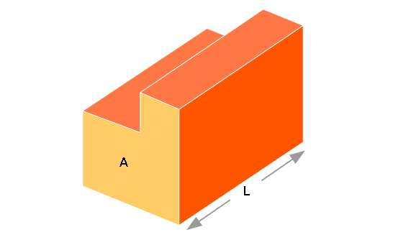**

1. Draw the net of the 3-dimensional shape

**Question 12** (**5 marks)**

A basketball coach draws a line across the court that is exactly 7m away from the hoop (as seen in the diagram below). He gets 3 players to stand on the line for a shooting drill; one is directly in front of the hoop with the other 2 players set up either side. One of the players protests and says that this setup is not fair. Is the player correct? Justify with calculations

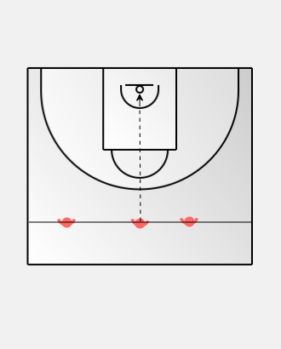

15m

4.5mm

5.5m

END OF TEST